Hands-on Exercise No. 2 – Solution
AI Using Python
DigiSkills 3.0 Batch-03

Task 1: Dataset Loading
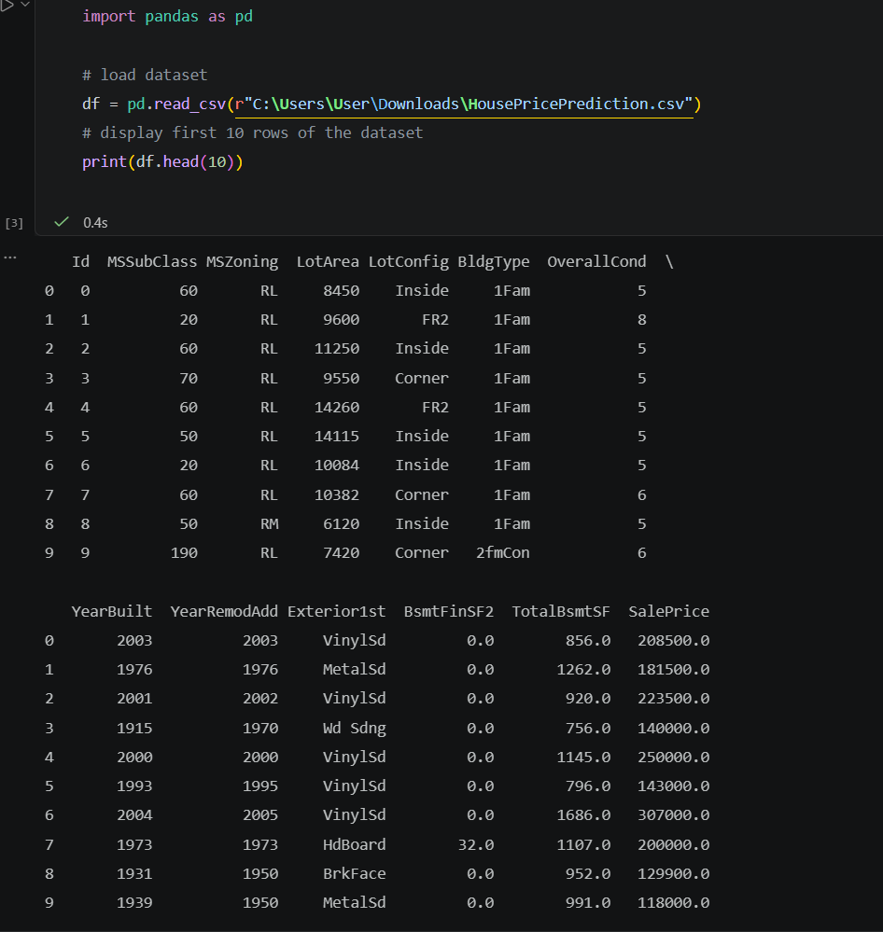

Task 2: Data Exploration
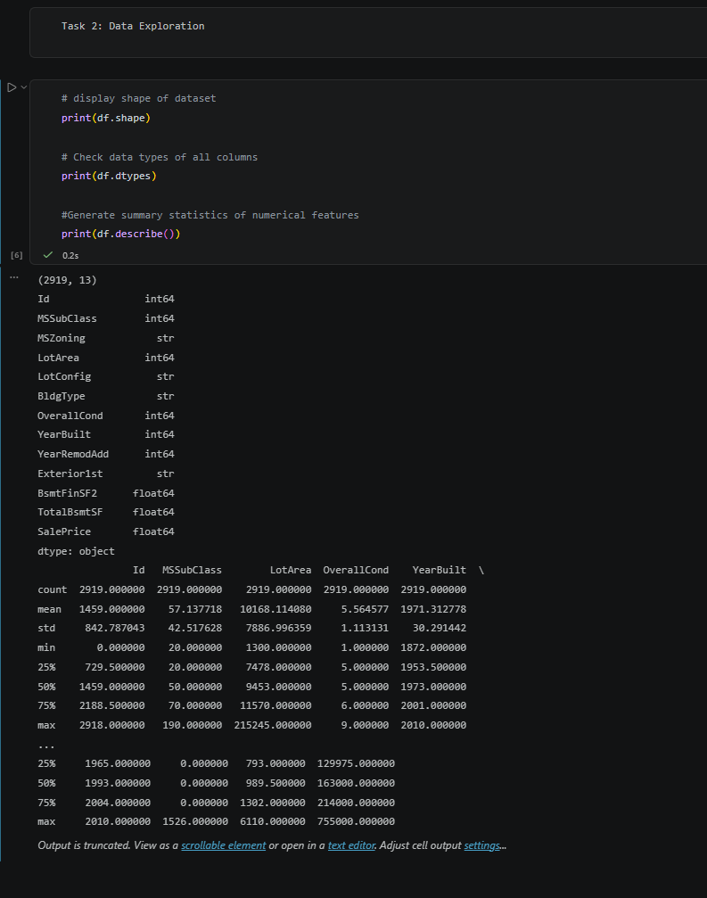

Task 3: Data Cleaning

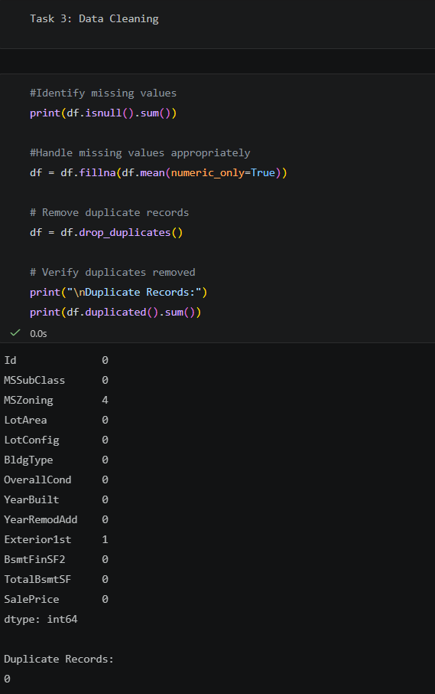

Task 4: Feature Selection
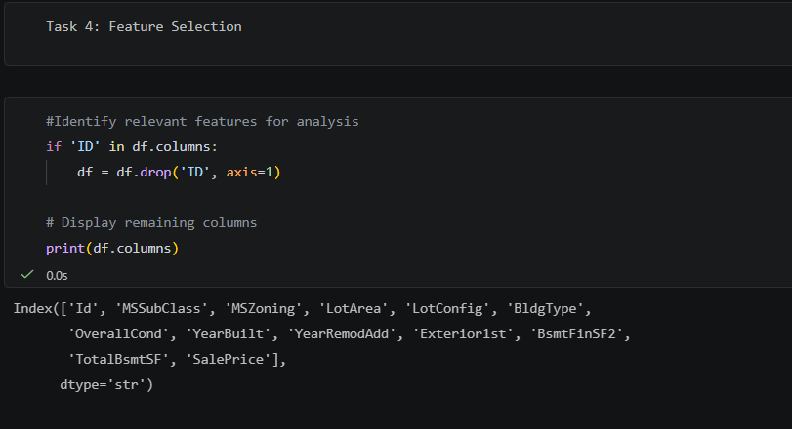
Task 5: Data Preprocessing

• Convert categorical variables into numerical form (encoding)
• Preparing the dataset for machine learning and display it’s preview in the output
